(2, -2)

What is the easiest method to solve

4x - 5y = 18

6x + 5y = 2

(0, 2)

Graphing

(1, 2)

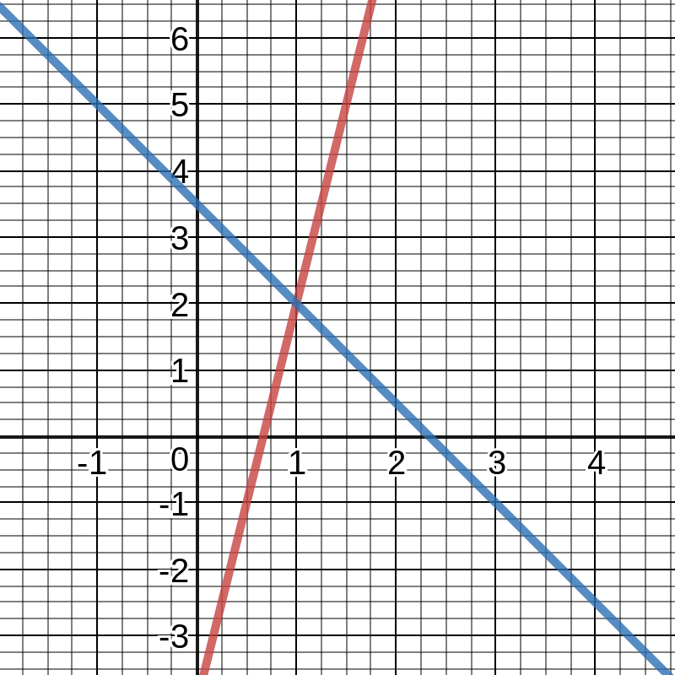

Substitution

Elimination

What is the easiest method to solve

y = 3x + 2

12x + 3y = 6

What is the easiest method to solve

y = 2x - 4

y = -3/2x + 6

System of Linear Equations

Two or more linear equations that meet once, always, or never.

One Solution

All Reals

No solution

Linear Systems have _______.

y = 3x + 4

y = 3x -4

y = 3x + 5

2y -6x = 10

Non-Linear, Linear, or Inequalities

Graphing

Inequalities

One or more solutions

Non-Linear Systems can have ______.

Systems can be _____.

The best way to solve an inequality is ______ .

What type of problem are these? (what are they called)

y < 9x - 4

y > -3x + 6